<https://in.linkedin.com/in/dr-ashis-jalote-parmar-0545925>

The right brain-left brain theory, originated in the work of Roger W. Sperry, who was awarded the Nobel Prize in

1981 in Physiology and Medicine for his work with split-brain research. It has been contested since, but no matter

the science, it is a fact that intuitive, creative thinking, usually attributed to the right hemisphere, is very

different from analytical thinking, attributed to the left one.

phrase "prove it" is the complete opposite of innovation; as you can only prove things that happened in the past. He says, a business person who wants innovation has to be open to the logic of what "might be", not only the logic of "what is".

expect business managers to start designing objects, but rather 'user experiences', or 'business models'

The business person is usually trained to do "analytical thinking"; analyzing the past to predict the future, in order to produce "reliability". The training of a designer is to create something that is not replicable from the past, and while his creation has to answer a design brief, it is mostly something he loves, infused with his own aesthetics

Creative intuitive thinking is messy, iterative, circular, all over the place. Analytical business thinking is linear; from A to B, it could zigzag to E and D, but not by too much... Every time the thinking leaves the straight lines, there is the worry of loosing time and "turning in circles". The creative thinking lives in the circles, whenever it takes straight lines the designer starts to worry about his/her level of creativity.....

For instance every time right brain thinking creatives were asked to find a solution to a problem, they would favor taking the untrodden route and come up with new novel ways of seeing things, with loads of different ideas about ways to proceed. Left brain thinking people would get puzzled at this approach and not even understand, what they considered, a senseless "waste" of time. They could not empathize (even when trying hard enough) with the intrinsic desire, that spurred intuitive thinkers to do things in novel ways, different than what had been done before.

Design Thinking is much easier to apply to business thinking, when managers and decision makers are not too far removed from the reality on the ground.

Lateral thinking is solving problems through an indirect and creative approach, using reasoning that is not immediately obvious and involving ideas that may not be obtainable by using only traditional step-by-step logic(Ref: Wiki)

“Design thinking is a human-centered approach to innovation that draws from the designer's toolkit to integrate the needs of people, the possibilities of technology, and the requirements for business success.” —Tim Brown, president and CEO

Thinking like a designer can transform the way organizations develop products, services, processes, and strategy. This approach, which IDEO calls design thinking, brings together what is desirable from a human point of view with what is technologically feasible and economically viable. It also allows people who aren’t trained as designers to use creative tools to address a vast range of challenges.

Design thinking is a deeply human process that taps into abilities we all have but get overlooked by more conventional problem-solving practices. It relies on our ability to be intuitive, to recognize patterns, to construct ideas that are emotionally meaningful as well as functional, and to express ourselves through means beyond words or symbols. Nobody wants to run an organization on feeling, intuition, and inspiration, but an over-reliance on the rational and the analytical can be just as risky. Design thinking provides an integrated third way.

The design thinking process is best thought of as a system of overlapping spaces rather than a sequence of orderly steps. There are three spaces to keep in mind: inspiration, ideation, and implementation. Inspiration is the problem or opportunity that motivates the search for solutions. Ideation is the process of generating, developing, and testing ideas. Implementation is the path that leads from the project stage into people’s lives.

Under this system, IDEO uses both analytical tools and generative techniques to help clients see how their new or existing operations could look in the future — and build road maps for getting there. Our methods include business model prototyping, data visualization, innovation strategy, organizational design, qualitative and quantitative research, and IP liberation.

All of IDEO’s work is done in consideration of the capabilities of our clients and the needs of their customers. As we iterate toward a final solution, we assess and reassess our designs. Our goal is to deliver appropriate, actionable, and tangible strategies. The result: new, innovative avenues for growth that are grounded in business viability and market desirability.

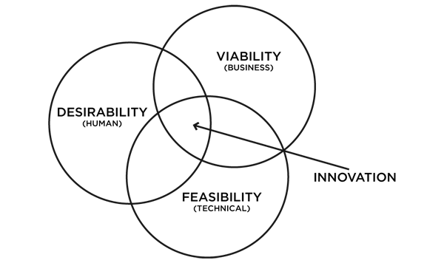

Read more at <https://www.ideo.com/about/#3Z7FtsPxAUky2mEJ.99>

Companies all over the world feel threatened due to continuously changing technology landscape with resulting change on society and market. Most of them wait for change to become more intelligible before acting on it.

Innovating is risky, not innovating is riskier.

Simple example, remember movie Lawrence of Arabia when the hero and his companion are sitting on a sand dune in the desert when they see a moving black spot in a distance, unable to discern what it is. Not knowing what to do, they wait and watch to see what it is. Gradually the spot becomes an animal in motion, then a camel, then finally a camel with a man riding on it. They are caught completely off guard as man on camel takes out his gun and kills Lawrence’s companion.

Their mistake was to wait and see what the threat might be in a hostile place. Any other move would have been better, running away, taking cover, firing a warning shot or anything else.

Companies sit in a similar boat. Market research though can identify these threats, will not always reveal them, the standard business solutions are of a little help. Design thinking brings a holistic vision to innovation.

So why innovate?

Any experience that is harmful emotionally, cognitively or aesthetically or otherwise disruptive to people’s well-being is a problem.   
Design thinking as name suggests is how designer thinks, drawing on a style of reasoning that is hardly conventional in the business world.

|  |  |  |
| --- | --- | --- |
|  | Design Thinking | Analytical Thinking or Market Research |
| Focus | People | People |
| Objective | Seeks to understand the culture, experiences, emotions, thoughts and behaviors to provide insight and inspiration for the project | Seeks to understand behavior through what people do, in order to predict how they would behave in a new situation, while coming up with solution based on their answers |
| Data Collection | Semi-structured conversations between researcher and the interviewed | Primarily through questionnaire and structured interviews |
| Sampling | Represents samples qualitatively and seeks profiles of extreme users, because unusual and obscure observations may lead to new and interesting ideas | Statistically represents the sample, with the intention of understanding the answers of the masses, commonly ignoring points off the curve. Data analysis requires and objective point of view that is critical and unbiased. |
| Type of information collected | Behavior, objects and words that people use to express the way they interact with things and processes around them | People’s opinions and behavior regarding current situations or expectations of future contexts. |

Immersion:

Usually a first stage, but not always. Design thinking is non-linear and any stage can permeate or be at the beginning.

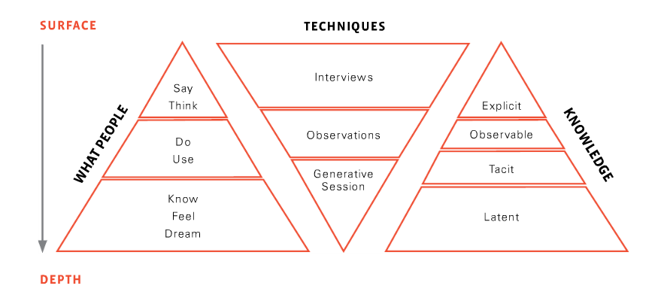

Cultural Probes:

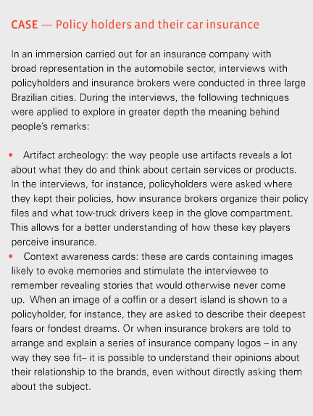

Shadowing:

